Subcode |  |  |  | GE6152
Subject Name |  |  |  | ENGINEERING GRAPHICS
Sem |  |  |  | 01
Degree |  |  |  | B.E
Branch |  |  |  | ALL BRANCHES
Staff Name |  |  |  | MR.K.ARUN,MR.RUSKINBRUCE,MR.M.SUBRAMANIAN
Date of Updation |  |  |  | 08.11.2013
Part | Unit | Group | Q. No | Question
B | 1 | 1 | 1 | Draw the locus of a point P moving so that the ratio of its distance from a fixed point F to its distance from a fixed straight line DD’ is 3/4. Point F is at a distance of 35 mm from DD’. Draw the tangent and a normal to the curve at any point on it.
B | 1 | 1 | 2 | Draw an epicycloid with the radius of the rolling circle and radius of the base circle equal to 30 mm and 100 mm respectively. Draw normal and tangent to the curve at a point, which is 120 mm from centre of base circle
B | 1 | 1 | 3 | A cord is unwound from a drum of 30 mm diameter. Draw the locus of the free end of the cord for unwinding through an angle of 360°. Draw also a tangent and normal at any point on the curve
B | 1 | 1 | 4 | Construct a conic section, whose distance between the moving point to focus and moving point to directrix are always same. The distance between the directrix to focus is 40 mm also draw a tangent and normal at a point 30mm below the axis. Also name the curve
B | 1 | 2 | 1 | Draw the orthographic views (front view, top view and a side view) for the given isometric views using free hand. Mark the dimensions  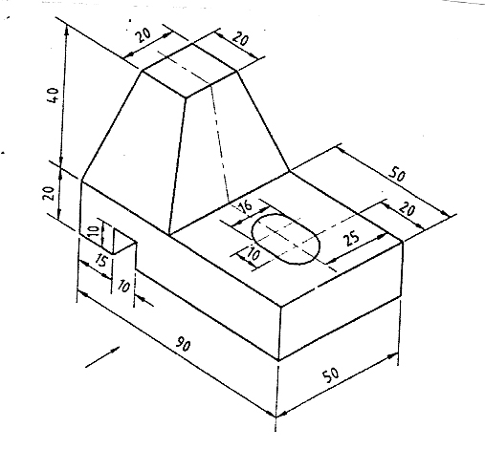
B | 1 | 2 | 2 | Draw the orthographic views (front view, top view and a side view) for the given isometric views using free hand. Mark the dimensions  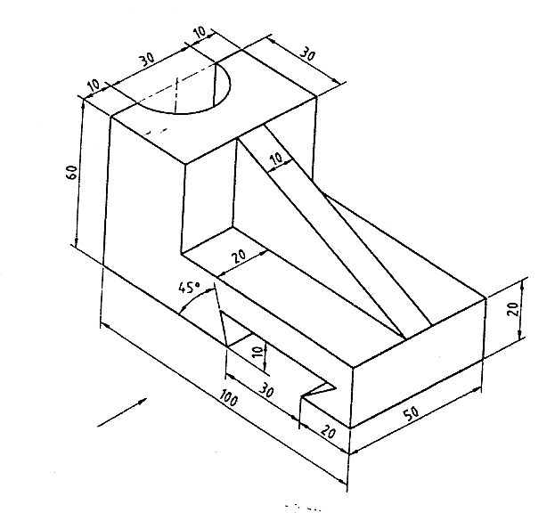
B | 1 | 2 | 3 | Draw the orthographic views (front view, top view and a side view) for the given isometric views using free hand. Mark the dimensions  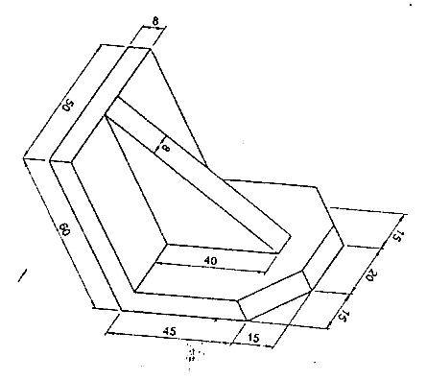
B | 2 | 1 | 1 | (i)A line AB 70 mm long has its end A 20 mm above HP and 25mm in front of VP. The line is inclined at 45° to HP and 35° to VP. Draw its projections, find the length of front and top view. Also mark its traces (10marks)  (ii) Draw the projection of points along a common reference line, with the 35mm in between projectors  - Point W, 27mm behind VP and 30mm above HP  - Point K, 0mm in front of VP and 25mm above HP  - Point A, on VP and 33mm below HP  - Point D, on both the principal planes  - Point H, 30mm AHP and the same distance BVP
B | 2 | 1 | 2 | A line AB 70 mm long has one of its end 60 mm above HP and 20 mm in front of VP. The other end is 15 mm above HP and in front of VP. The front view of the line is 55 mm long. Draw the top view and find the true inclinations.
B | 2 | 1 | 3 | The midpoint of a line PQ 70 mm long is 35 mm above HP and 50 mm in front of VP. It is inclined at 35° to HP and 45° to VP. Draw its projections
B | 2 | 1 | 4 | A line measuring 65mm long has one of its ends 45mm in front of VP and 20mm above HP. The top view of the line is 45mm long. The other end is 20mm infront of VP and is above HP. Draw its projections and find the true inclinations with HP and VP
B | 2 | 2 | 1 | A pentagonal lamina of side 30 mm rests on the ground on one of its corners with the sides containing the corner being equally inclined to the ground. The side opposite to the corner on which it rests is inclined at 30° to VP and is parallel to HP. The surface of the pentagon makes 50° to the ground. Draw the projections of the lamina
B | 2 | 2 | 2 | A hexagonal plate of side 30 mm is resting on one of its sides on VP and inclined at 40° to HP. The surface is inclined at 35° to VP. Draw its projections
B | 2 | 2 | 3 | - Draw the projections of a circular plate of diameter 50 mm resting on the ground on one of its points on circumference such that its surface is inclined at 30° to HP. Plan of diameter on the resting point makes 45° to VP.
B | 2 | 2 | 4 | A rectangular plate 70 mm x 40 mm has one of its shorter edges in the VP inclined at 40° to the HP. Draw its top view, if its front view is a square of side 40 mm
B | 3 | 1 | 1 | A pentagonal pyramid of base side 30 mm and axis length 60 mm is resting on the HP on one of its triangular faces with its axis parallel to the VP. Draw the projections using auxiliary plane method
B | 3 | 1 | 2 | A hexagonal prism of base side 30 mm axis length 60 mm is resting on the HP on one of its base sides with its axis inclined at 40⁰ to the HP and parallel to the VP. Draw its projections using auxiliary plane method
B | 3 | 1 | 3 | A cone of base diameter 50 mm and axis length 60 mm is resting on the HP on one of its generators with its axis parallel to the VP. Draw its projections using auxiliary plane method
B | 3 | 2 | 1 | A hexagonal pyramid of base side 25mm and height 65mm is kept, such that the base is parallel to VP and 20mm in front of VP with two of its base edges perpendicular to HP. Draw its projections
B | 3 | 2 | 2 | A square pyramid of base side 30mm and axis height 50mm is lying on the HP on one of its triangular faces with its axis parallel to VP. Draw the projections of the pyramid
B | 3 | 2 | 3 | A pentagonal pyramid of base side 35mm and axis height 80mm is freely suspended from one of its base corners, such that the axis is parallel to VP. Draw the projections of the solid
B | 3 | 2 | 4 | Draw the projections of a pentagonal pyramid of base edge 25mm and axis 60mm rests on the base side on HP such that the highest base corner is 20mm above HP and axis parallel to VP
B | 4 | 1 | 1 | A cube of side 35mm rests on the HP on one of its faces with a vertical face inclined at 45° to the VP. It is cut by a plane perpendicular to the VP and inclined at 30° to the HP and meeting the axis at 25mm above the HP. Draw the front view, sectional top view and the true shape of the section
B | 4 | 1 | 2 | A cone diameter 40mm and axis 50mm rests on base on HP. An auxiliary plane inclined at 45° to HP cuts the cone and passes through a point on axis which is 20mm above HP. Draw sectional plan and elevation and the true shape of the section
B | 4 | 1 | 3 | A hexagonal prism of base side 25mm and height 50mm rests on the HP on one of its ends with two rectangular faces parallel to the VP. It is cut by a plane perpendicular to the HP and inclined at 50° to the VP at a distance of 10mm from the axis. Draw the top view, sectional front view and true shape of the section
B | 4 | 1 | 4 | A pentagonal pyramid of base side 25mm and altitude 60mm rests on the HP on its base with an edge of the base parallel to the VP. It is cut by a vertical plane inclined at 45° to the VP at a distance 8mm from the axis. Draw the top view, sectional top view and the true shape of the section
B | 4 | 2 | 1 | A hexagonal pyramid of side of base 30 mm and axis 70 mm rests on its base with the edges of the base parallel to the VP. A circular hole of diameter 30 mm is completely drilled through the pyramid such that the axis of the hole is perpendicular to the VP and intersects the axis of the pyramid 20 mm above the base. Draw the development of the lateral surface of the pyramid showing the true shape of the hole formed on it
B | 4 | 2 | 2 | A cone, base 54 mm diameter and height 72 mm, rests with its base on the HP. A section plane perpendicular to the VP. and inclined at 25 degrees to the VP. cuts the cone at a distance of 13.5 mm from the axis. Draw the sectional front view and develop the lateral surface of the remaining portion of the cone
B | 4 | 2 | 3 | A cylinder of diameter 40 mm and height 60 mm is resting vertically on one of its ends on the HP. It is cut by a plane perpendicular to the VP and inclined at 30 ⁰ to the HP. The plane meets the axis at a point 40 mm from the base. Draw the development of the lateral surface of the lower portion of the truncated cylinder
B | 5 | 1 | 1 | A frustum of a cone has its top and bottom diameters 35mm and 50mm respectively and altitude 53mm, it rests on the top face of a frustum of a square pyramid, the sides of the top and the bottom faces of the pyramid are 58mm and 70mm respectively, the height is 22mm. Draw the isometric view
B | 5 | 1 | 2 | Draw the isometric view of a pentagonal pyramid of base side 30mm and height 70mm, which rests on its base on HP with a base edge parallel to VP. It is cut a plane perpendicular to VP, inclined at 45° to HP and meeting the axis at 40mm from base
B | 5 | 1 | 3 | A cube of side 40mm is kept above a cylinder of 65mm diameter and 40mm height, both the solids have the common axis. Draw their isometric view
B | 5 | 2 | 1 | A cube of side 45 mm is resting on its base with all vertical faces equally inclined to the PP, one vertical edge touching the PP and 10 mm to the left of the station point which is 70 mm above ground and 65 mm in front of the PP. Draw the perspective projection
B | 5 | 2 | 2 | A cylinder of diameter 40 mm and height 40 mm rests on the GP on one of its ends with its axis 35 mm behind the picture plane. The station point is 45 mm to the right of the axis . The station point is 65 mm above the GP and 40 mm in front of the PP. Draw the perspective projection of the cylinder by visual ray method
B | 5 | 2 | 3 | A pentagonal pyramid of 30 mm base side and axis height 40 mm is standing on its base on the ground plane with a base side parallel to and 25 mm behind the PP . The central plane is 35 mm to the left of the apex and the station point is 40 mm in front of the PP and 20 mm above the ground plane . Draw the perspective view of the pyramid

Note :
- Name of the file should be same as subject code [for example MA6151.doc]
- Last date to submit the question bank at exam office for
I Yr UG & I Yr PG – 9.11.2013

MANAGING DIRECTOR

